Title:

Home Workout Without Equipment

Package ID:

id=com.mjtechnologies.mjhomeworkout.gymworkout.homeworkouts.noequipment.workoutathome.musclebuilding.prohomeworkout

if you think the package id is lengthy then remove last work prohomeworkout.

First Splash Screen

After splash screen we will collect details about the user with this senior.

Gender – Height in cm and ft – Weight in kg and lbs   
it depend on user he/she can add weight in kg or lbs and also weight in cm and ft

For this follow this app: Gym workout tracker : Gym log https://play.google.com/store/apps/details?id=gymworkout.gym.gymlog.gymtrainer

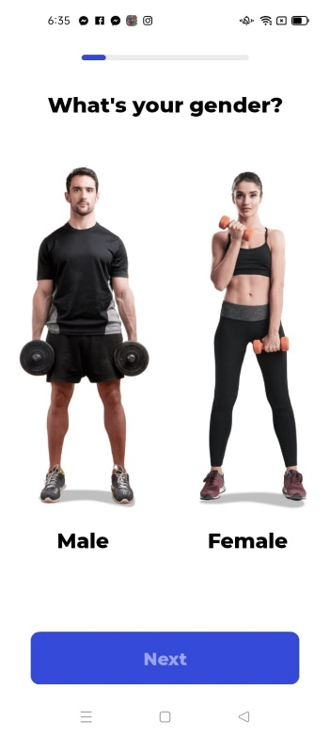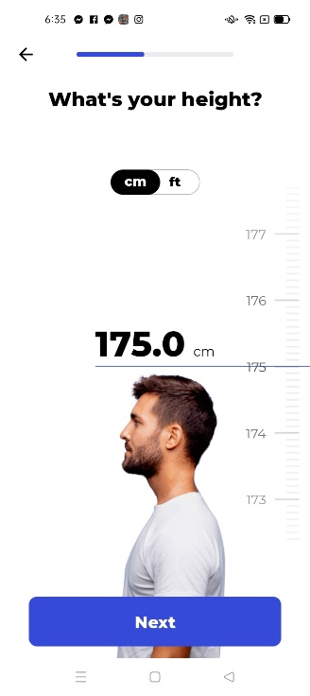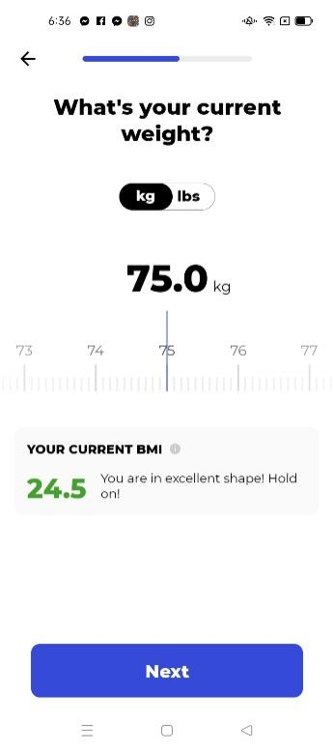

After this There are 4 tabs  
Home – Challenge – Weight - Profile

Follow this app: <https://play.google.com/store/apps/details?id=com.akashlilhare.homeworkout>

Home Screen

This main layout then stretches then chest - Shoulder - abs- legs -arms

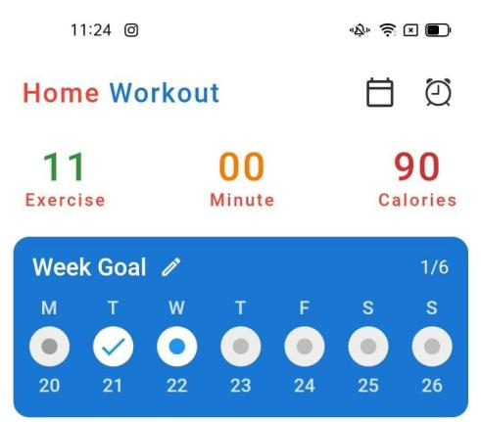Follow this app home workout no equipment

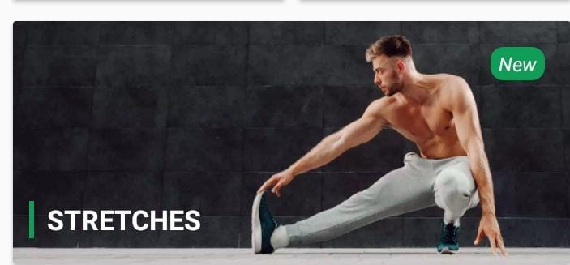 Follow this app Fitvate

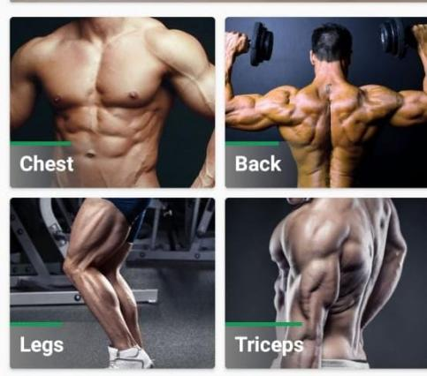 Chest - shoulder - abs - Legs - Follow this app home workout no equipment

 Arms Follow this app home workout no equipment

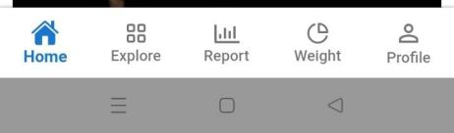 Follow this app home workout no equipment

Name of these tabs: Home - Challenge – Weight - Profile

When user click on the Stretches then it will redirect to the stretches exercise  
and we show all the stretches exercise in the tab section  
name: all- chest-back-legs-triceps- abs-forearm-biceps-buttock-shoulder-cardio-calf-traps

Follow this app: fitvate

In all section user will get all the stretches in randomly just for one time

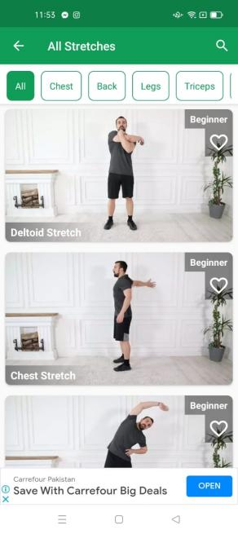

Now if user click on the chest then it will only show chest stretches but if user click on anyone chest stretches it will redirect to the next level and the remaining will show in the below

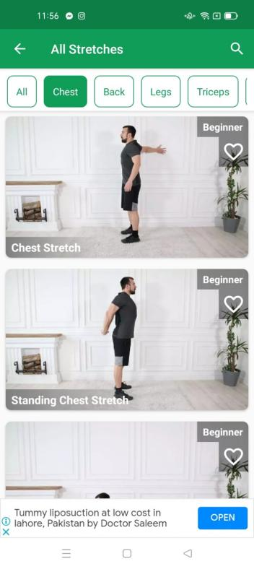 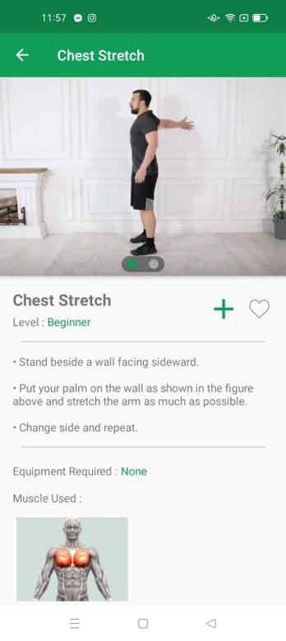 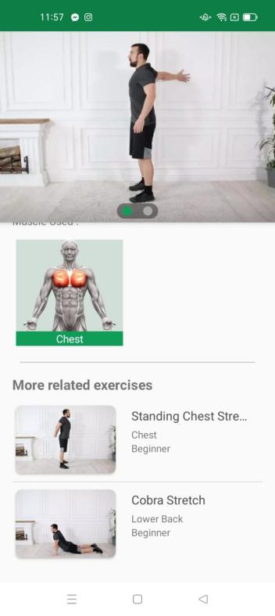

for all the others stretches and follow this app fitvate

Now next part if user click on the Chest - shoulder - Abs- legs-arms the the relevant screen are below

Follow home workout no equipment

**Chest**

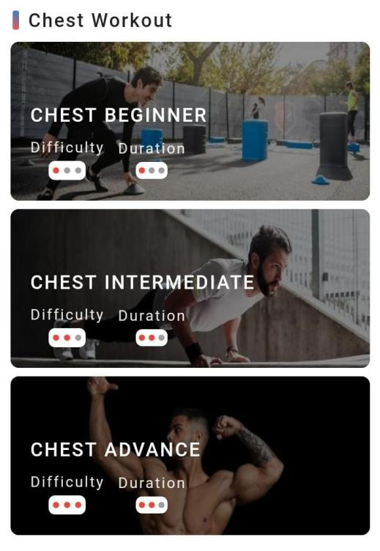

**shoulder**

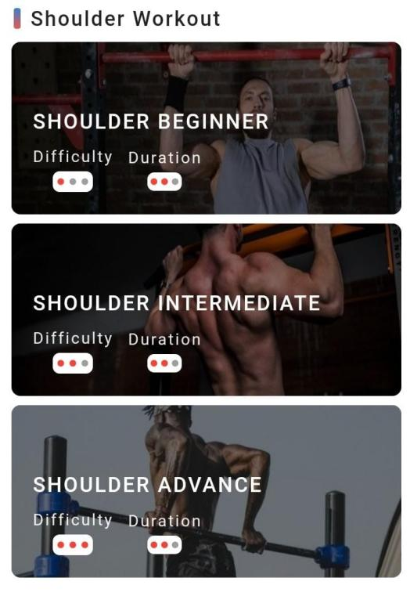

**Abs**

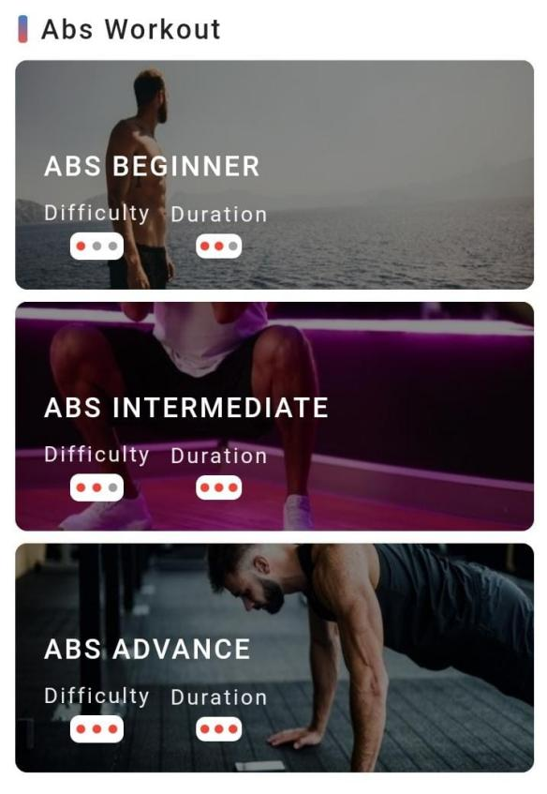

**Legs**

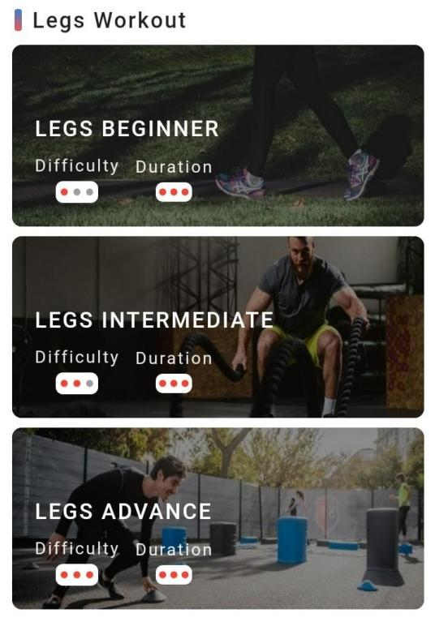

**Arms**

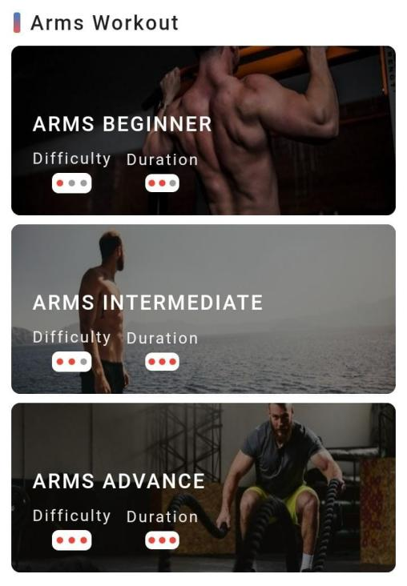

Now if user click on the chest beginner then the next screen will be

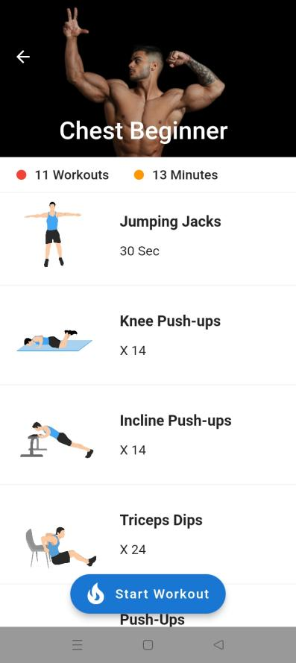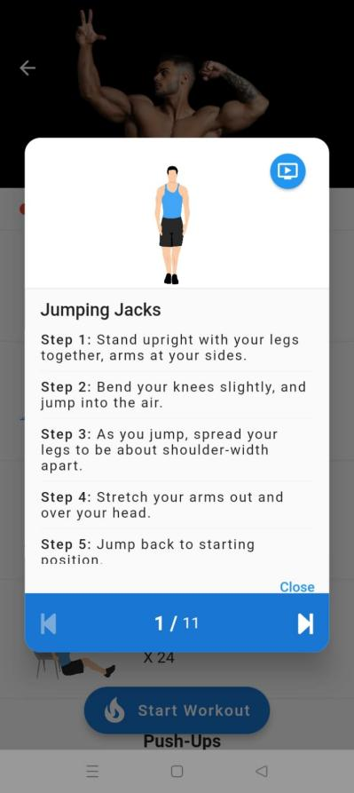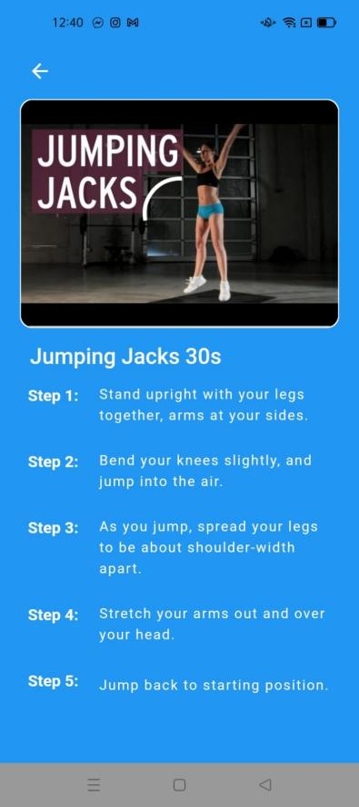

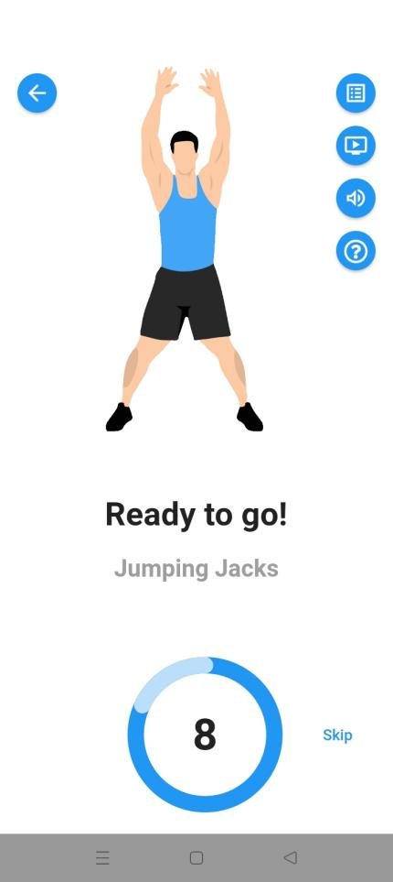 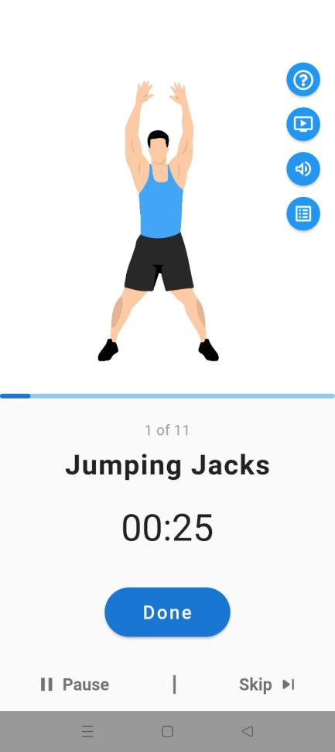 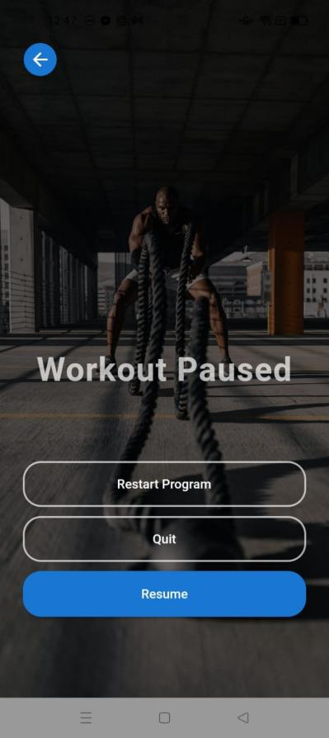

If user click on the errow or resume he/she will redirect to the exercise if user click on the quit then one pop is with yes or not if no then main screen remain same if yes he/she will redirect o the main layout and if user click on the restart programme then one pop show with cancel and quit if click on the cancel then main screen of the pause come and if click on the restart then redirect to the start workout screen.

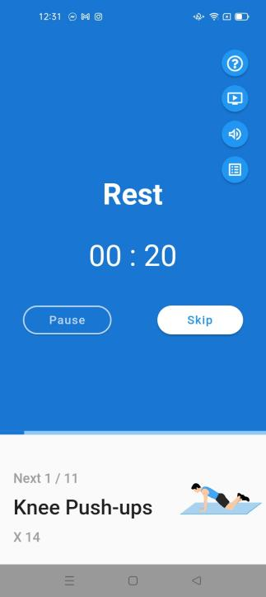 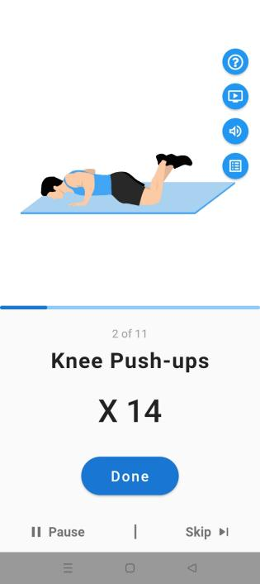 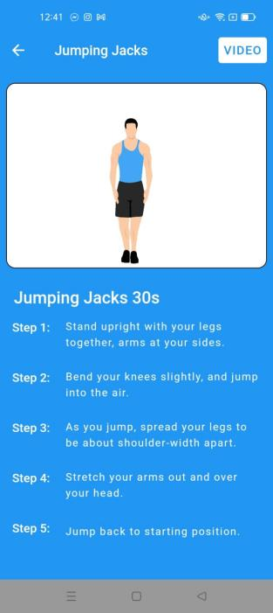 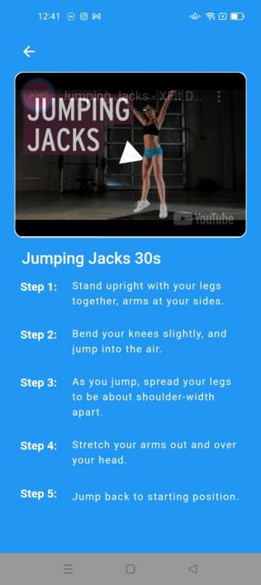

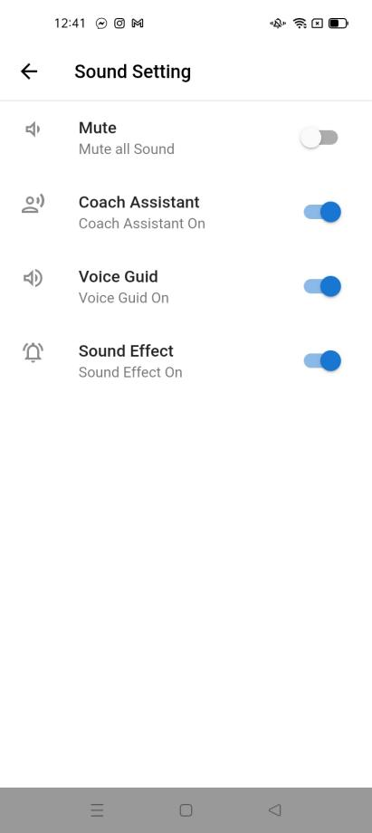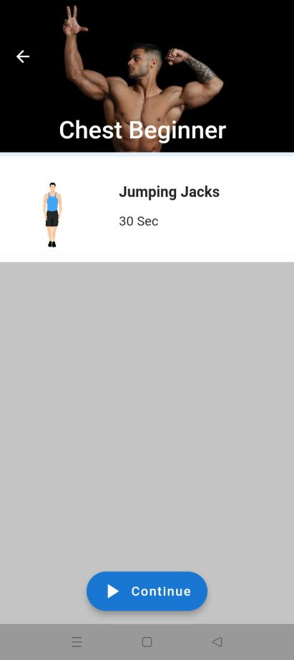

For profile section copy the app.

Basically we need clone of this app… Home workout no equipment

Apps links that are reference for this app

Home workout no equipment: https://play.google.com/store/apps/details?id=com.akashlilhare.homeworkout

Fitvate: <https://play.google.com/store/apps/details?id=com.fitvate.gymworkout>Gym workout tracker : Gym log: https://play.google.com/store/apps/details?id=gymworkout.gym.gymlog.gymtrainer